AKAI APC40 MKII
Controller script for Bitwig Studio

Introduction
This controller script is made to control the AKAI APC40 MKII. Here is a link to the product page: http://www.akaipro.com/product/apc40-mkii
This scripts will help you to perform your projects in the mixer view. It is made to be simple, direct and efficient. You should see it as a performance tool and not a production tool.

Main features of the script
- Launch and stop clips
- Launch scenes
- Visual feedback of the clip status (playing, queued, recording, …) with colors
- Start the playback, Record to the Arranger or the Mixer clips
- Move the clip launcher window
- Select tracks
- Enter and Leave groups (by using nudge+/-)
- Set the track Solo, Mute, Arm, A/B deck, Pan and Volume
- Cross-fade between Deck A and Deck B
- Bank of 5 sends per track
  - Select the FX track when selecting the send and control the Send FX device
- 8 x 5 user controls
- 8x Device Remote Controls
- Navigate to Previous or Next Device
- Navigate to Previous or Next Remote Control Page
- Pin device
- Enable or Disable device
- Show the plugin window
- Cycle through detail panels (Editor, Automation, Device lane)
- Change the default launch quantization
- Enable the Metronome, Set or Tap the Tempo

The device

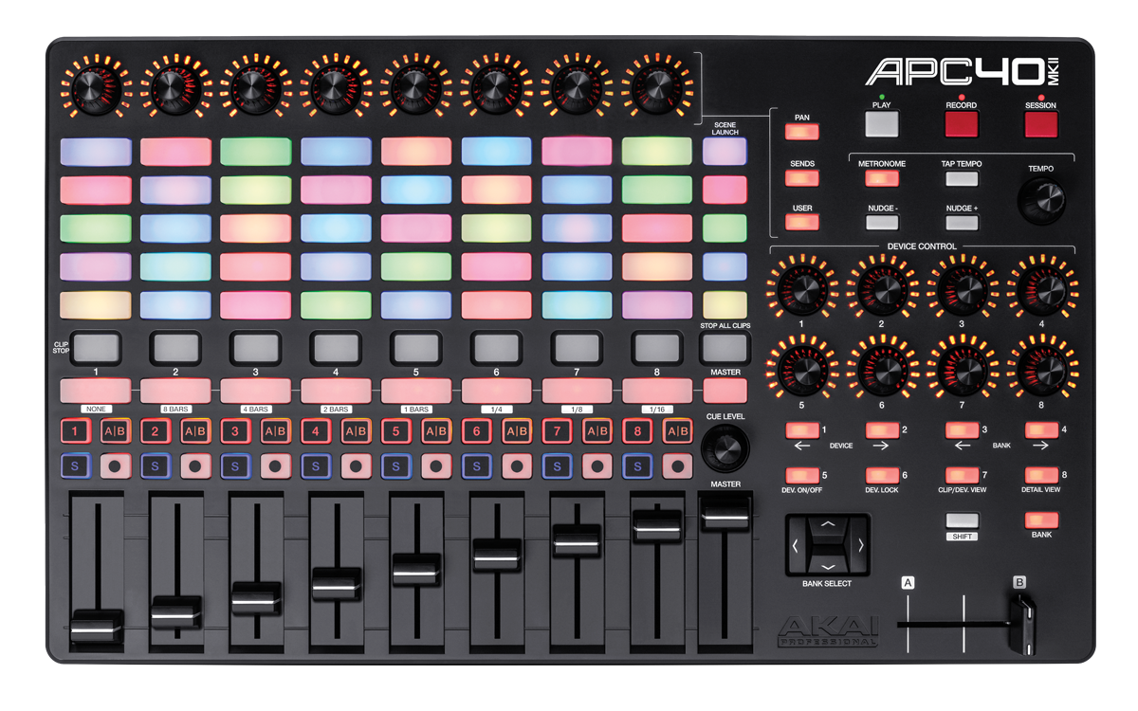
The script is doing what is written on your controller, so there is no need to explain what is trivial.

Transport control
The play button will start the transport.
The record button will enable overdub in the clip launcher, if you press shift, it will enable recording in the arranger.
The session button will start recording automation in the clip launcher, if you press shift, it will enable automation recording in the arranger.
You can tap the tempo with the tap button or use the tempo knob. The tempo knob will increase the tempo by +1/-1. If you press shift while using the tempo knob, it will increase the tempo by +0.1/-0.1.
The metronome button will enable or disable the metronome.
The nuge buttons can be used to enter track group or exit track group.

Top knobs – Pan / Sends / User
The top knobs can be used for 3 different tasks: Pan, Sends and User.
To use the Pan mode, press the pan button and the knobs will display and control the corresponding pan of the track.
As Pan is not useful to everyone, there is an option to use an alternative channel strip mode. In channel strip mode, the first four knobs will control the latest device on the track, and the next four knobs will control four sends.
To use the sends mode, press the sends button. You will notice that the scenes launchers changes while you hold the sends button and can now be used as a send target selection. The current send target will be in yellow and the other in blue. You can choose between the first and the fifth send target. If you press shift while you release the sends button, then the send selector will be held. There is an option to select the fx channel and control its FX device after selecting the send from the scene launch column.

The user mode is a bit special, it gives access to 5 x 8 custom knobs that can be mapped to any Bitwig controls. So until they are manually mapped, they won’t do anything.
To use the user mode, press the user button. You will notice that the scenes launchers changes while you hold the sends button and can now be used as a user target selection. The current user target will be in yellow and the other in blue. You can choose between the first and the fifth user target. If you press shift while you release the user button, then the user selector will be held.

Bank select
Bank select is used to scroll the clip launcher window. It will scroll to the left, right, top or bottom by one track or scene. If you press shift then it will scroll by block of 8 tracks or 5 scenes.

Device Controls
This part maps the current device’s remote controls those 8 knobs.
You can select the remote control page using the bank left and right button.
You can select the current device using the device left and right button.
You can turn on/off the current device using the dev on/off button.
You can pin one device using the dev lock button. It means that each time you select the track which contains the pinned device, then the pinned device will become the selected device.
When you press the bank button, then the 8 buttons under the device control knobs becomes page selector for the the device remote controls. So you can with one button select any of the first 8 remote control pages. If you want to hold that mode, press shift before you release the bank button.

Default launch quantization
Press Shift and then one of the track select button.

